

MAINTAINABLE FUEL FILTER

P/N 1090079

Airflow Performance, Inc.
111 Airflow Dr.
Spartanburg, SC 29306
864-576-4512
www.airflowperformance.com

FUEL FILTER

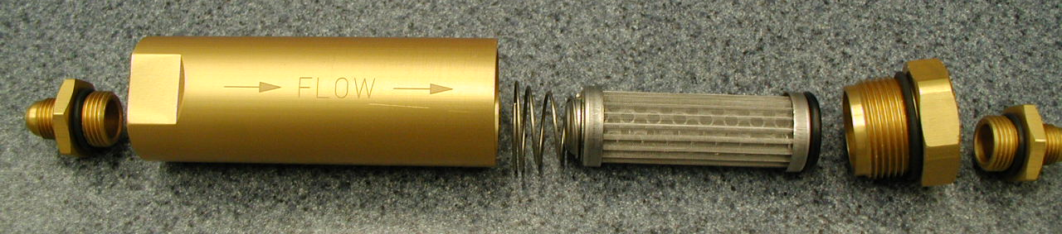
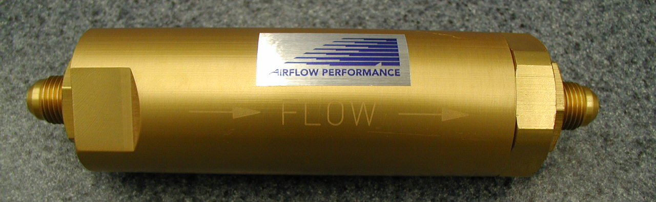
  - A fuel filter should be installed in the system before the fuel boost pump, and after the selector valve. The filter may also incorporate a gascolator. If this type of device is used, then the gascolator should be installed at the lowest point in the fuel system. Airflow Performance does not approve the use of any paper element type fuel filter. Paper element filters will restrict the inlet of the fuel pumps due to their fine filtration and their susceptibility to clogging from picking up water. If the inlet of the fuel pumps are restricted, the pressure on the inlet becomes depressed, this will cause the fuel to boil and the vapor will flow into the fuel controller causing it to malfunction. This problem is not as evident when float carburetors are used, since the float chamber will allow the fuel vapor and bubbles to escape. A screen type filter should be used. The filter size must be based on the total fuel flow through it, not just the engine fuel consumption. This again depends upon the type of fuel system in the aircraft, returning or non-returning. The filter Airflow Performance recommends for this application is P/N 1090079. This a maintainable filter incorporating a 125 micron pleated stainless steel filter element with a anodized aluminum housing. The filter should be in stalled in the aircraft so that periodic cleaning can be performed. It can be clamped by using -26 Adel clamps around the filter body to support it securely to the airframe structure. It is recommended that the filter be installed on the cool side of the firewall. No other filters are necessary in the system.
P/N 1090079 Maintainable Fuel Filter

The filter can be cleaned periodically by removing the filter from the fuel system, un-screwing the end cap of the filter assembly with a 1 ½” wrench while holding the other side of the housing with a 1 3/8” wrench or vise. The filter should be inspected after 5-10 hours of operation on new installations and then typically every year at the condition inspection after that. Inspect more frequently if known fuel conditions are questionable. The filter element can be removed from the filter cap and cleaned in mineral spirits then blown dry with compressed air. Inspect the seal O-rings. These may be re-used if in satisfactory condition. Re-assemble the filter using some engine oil on the O-rings. Make sure the conical spring is installed as per the picture and the filter assembly is installed back in the fuel system in the correct flow direction as designated by the arrows on the filter housing..

P/N 1090079 MAINTAINABLE FUEL FILTER
Filter Fitting
P/N 1090088
Filter Housing
P/N 2090188
Spring
P/N HW2906
Filter Element
AH7915-01
Filter Cap
P/N 2090189
O-Ring
P/N OR-2210.V75
O-Ring
P/N OR-2123.V75
O-Ring
P/N OR-908.V90
O-Ring
P/N OR-908.V90
Filter Fitting
P/N 1090088

