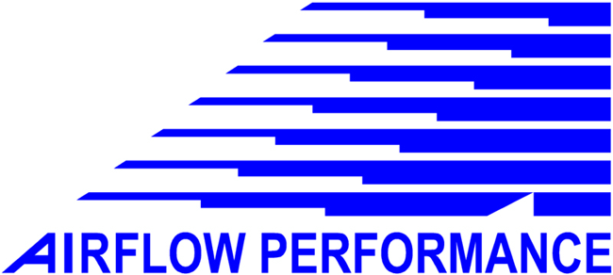

Aircraft Boost Pump

P/N 3090050

Airflow Performance, Inc.
111 Airflow Dr.
Spartanburg, SC 29306
864-576-4512
www.airflowperformance.com

BACKGROUND

- A fuel boost pump is required for engine starting and as an emergency back up to the engine driven pump. The pump must produce the pressure and flow required to support the engine fuel requirements at maximum HP in the event of an engine driven pump failure. Weldon and Dukes pumps (these are common boost pumps used on certified aircraft) can be installed in line since these pumps incorporate integral bypass and relief valves. The relief valve on the boost pump should be set a few PSI higher than the engine driven pump operates at to verify that the boost is running when it is turned on. Ideally the boost pump should be installed in the system so that under normal flight attitudes the pump inlet will be gravity fed from the fuel supply. If this condition cannot be satisfied, check with the manufacture of the boost pump to determine the dry suction lift capability of the pump. Making the pump draw fuel will increase the possibility of getting fuel vapor or bubbles in the fuel system, causing malfunction of the fuel controller, and can cause premature failure of the boost pump.

INSTALLATION

- It is recommended that the boost pump be mounted in the aircraft behind the firewall. This will keep the pump in a cooler environment and will tend to keep vapor lock and hot operation problems to a minimum. In installations where the boost pump must be mounted on the firewall, it advisable to enclose the pump package in a box and flow blast air through the box. This will keep cooling air flowing through the box in flight and minimize heat soak during shut down. If the gascolator is located on the firewall it should also be installed in the box.

- 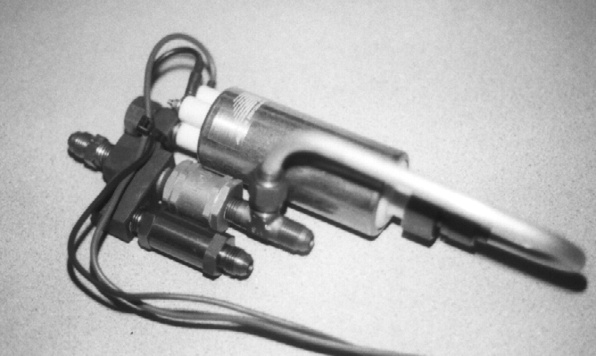The Airflow Performance aircraft boost pump, P/N 3090050 uses a high-pressure roller vane type fuel pump. This type of pump requires a relief valve to bypass fuel when the pump is running, which keeps the pump cool and sets the pressure to the system. The relief valve (25 PSI) is built on to the boost pump package. The relief valve is not adjustable. The return fuel should be plumbed to the sump tank (if one is used), to the fuel filter or gascolator inlet, teed to the boost pump inlet, or teed to the selector valve outlet. A bypass swing check valve is incorporated into the boost pump package, so that when the boost pump is not running, fuel will bypass the boost pump and flow directly to the engine driven fuel pump. This pump package will draw 5 amps at 12 VDC. The pump should be protected by a 7 to 10 amp circuit breaker. Electrical wiring to the pump should be a minimum of 16 gauge-stranded wire. The pump is supplied with 14-gauge wire. Use connectors on the airframe wiring to connect to the existing pump package wiring. Mount the pump package by using MS21919WDG29 (cushion clamps) clamps around the pump body and or the relief valve housing to support it securely to the airframe structure. If two clamps are placed around the pump body, it may be necessary to trim the rubber on the outside of the clamp to provide clearance between the pump motor and the bypass valve. The pump package can be mounted in any position. All connections on this pump package are –6 AN male fittings.

- All Airflow Performance pumps are continuous duty. The maximum dry suction lift of this pump is 2 feet. It is recommended that the pump be mounted as low as possible to the fuel supply to insure quick priming and minimize vapor problems. A flooded inlet is preferred.

- 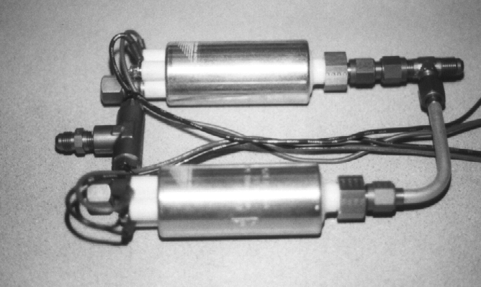There are some installations where no engine driven fuel pump is used. In this case a dual electric pump package should be used. The pumps should be connected to separate electrical supplies to provide a redundant pump in case of a primary electrical system failure. The pumps incorporate internal check valves to prevent fuel from flowing backward through the inactive pump. The pump package can be mounted using 3 MS21919WDG29 (cushion clamps). Secure two clamps to one pump motor and one clamp to the other pump motor.

- Some pump packages are available with an integral relief return line plumbed to the inlet of the pump. The example shown is an assembly for the M-14P radial engine. It has –8 AN fittings for the inlet and out let.

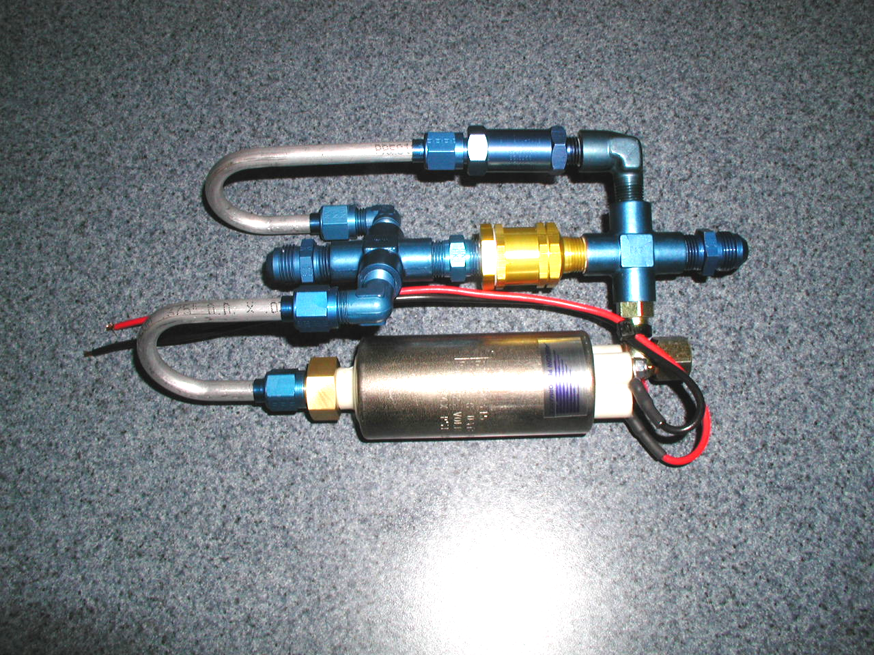
Relief return line plumbed to inlet of pump.
P/N 3090098-5 M-14 Pump Package

WARRANTY OF PUMP PACKAGES

All pump packages are tested in house to insure proper operation of the pump motor; correct pressure out put, correct flow out put and the assembly has been tested for external leakage.

- There will be no warranty on the pump motor P/N W-7135X.
  - Do not run this pump without fuel.
  - Water contamination will ruin the pump.
- Removing the supplied electrical wires will void the warranty.
- Removing or changing the supplied pump package fittings will void the warranty.
- If the supplied pump inlet tube assembly or fittings do not fit your installation, please contact Airflow Performance, Inc.

Pump Motor P/N W-7135X
Pump Package inlet
Pump Package relief valve
Pump Package outlet
Pump Package swing check valve
P/N 3090050 Boost Pump Package

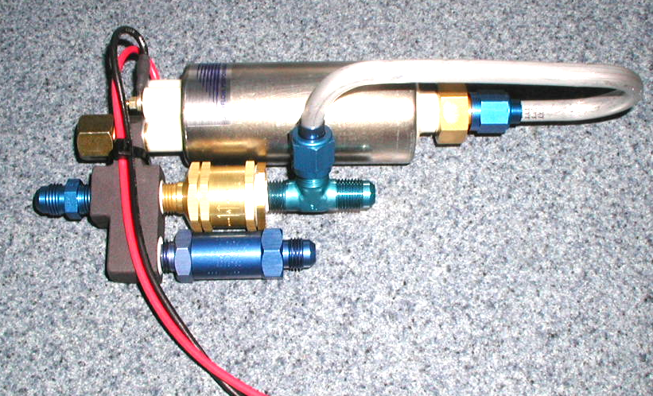

FUEL SYSTEM SCHEMATICS

The following schematics are for numerous installations. There are variations of the descriptions also. The table below describes a typical application where the particular schematic may apply. If you have a unique application where the schematic does not quite apply, contact Airflow Performance for further information.

INDEX OF APPLICATIONS
SCHEMATIC # | DESCRIPTION | TYPICAL APPLICATION
1 | Diaphragm engine driven fuel pump with electric boost pump mounted in airframe. | RV series, Lancair, Glasair; preferred installation using Lycoming engines with down draft cooling. This is a typical tractor engine installation
2 | Diaphragm engine driven fuel pump with electric boost pump mounted on firewall. | Long EZ, Cozy, typical Lycoming installation on rear engine aircraft using updraft cooling. The boost pump and filter are mounted low on the firewall in the stream of incoming cooling air.
3 | Single fuel tank installation. Diaphragm engine driven fuel pump with electric boost pump in airframe. | Pitts, One Design. Lycoming engine installations with down draft cooling.

FUEL SYSTEM SCHEMATIC 1
FILTER P/N 1090079
Alternate Location
AIRCRAFT BOOST PUMP PACKAGE P/N 3090050
ENGINE DRIVEN DIAPHRAGM FUEL PUMP
LW-15473
FUEL PRESSURE GAUGE 0-60 PSI
TO FUEL CONTROLLER
GAUGE RESTRICTOR
.016-. O20 DIA.
FUEL SELECTOR VALVE
FUEL TANK
FUEL TANK
FIREWALL
3/8 TUBING
3/8 TUBING
3/8 TUBING
-3 HOSE
-6 HOSE
FIRE SLEEVE ALL HOSE ON ENGINE SIDE OF FIREWALL
-6 HOSE
FUEL TANK VENT
FUEL TANK VENT
SUMP DRAIN
SUMP DRAIN
FILTER P/N 1090079 Preferred Location
Preferred location

FUEL SYSTEM SCHEMATIC 2
ENGINE DRIVEN DIAPHRAGM FUEL PUMP
LW-15473
AIRCRAFT BOOST PUMP PACKAGE P/N 3090050
FUEL PRESSURE GAUGE 0-60 PSI
TO FUEL CONTROLLER
GAUGE RESTRICTOR
.016-. O20 DIA.
FUEL SELECTOR VALVE
FUEL TANK
FUEL TANK
FIREWALL
3/8 TUBING
3/8 TUBING
3/8 TUBING
-3 HOSE
-6 HOSE
FIRE SLEEVE ALL HOSE ON ENGINE SIDE OF FIREWALL
SUMP DRAIN
SUMP DRAIN
ENCLOSE BOOST PUMP AND GASCOLATOR IN INSULATED BOX. PROVIDE BLAST AIR.
GASCOLATOR or P/N 1090079 Filter
FUEL TANK VENT
FUEL TANK VENT

FUEL SYSTEM SCHEMATIC 3

TO FUEL CONTROLLER
AIRCRAFT BOOST PUMP PACKAGE P/N 3090050
ENGINE DRIVEN DIAPHRAGM FUEL PUMP
LW-15473
FUEL TANK
3/8 TUBING
FUEL TANK VENT
SUMP DRAIN
GAUGE RESTRICTOR
.016-. O20 DIA.
FIREWALL
3/8 TUBING
-3 HOSE
-6 HOSE
FIRE SLEEVE ALL HOSE ON ENGINE SIDE OF FIREWALL
FUEL PRESSURE GAUGE
0-60 PSI
FUEL FILTER
P/N 1090079
FUEL SHUT OFF
VALVE

